
The Gruffalo’s Child – Knowledge Organiser
Talk Through Stories
Spring 1 Core Story
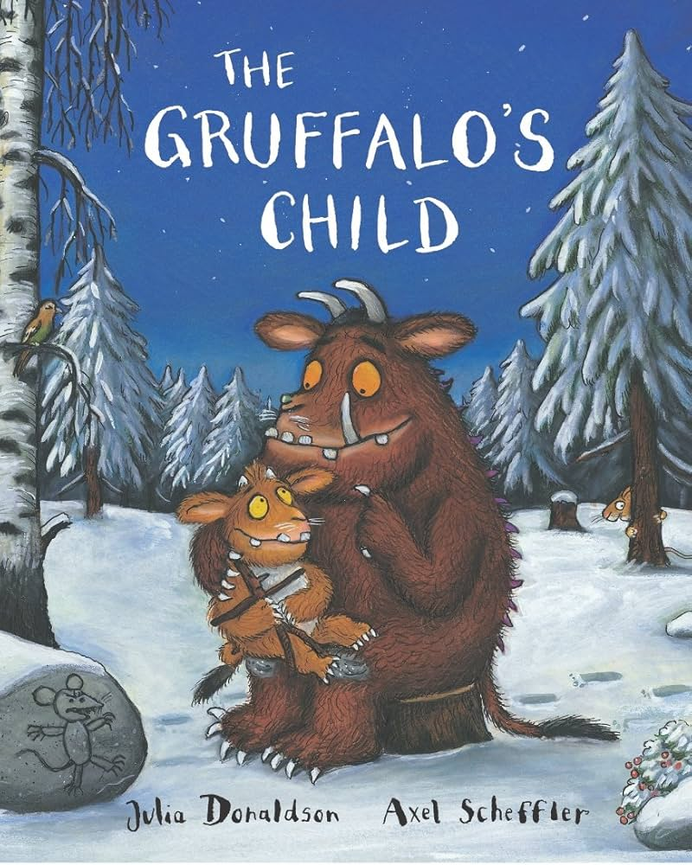
We help children love each story and go on to use ‘Tier Two’ words (words they rarely encounter in every day conversation) from the story in everyday contexts.
This extends and deepens vocabulary so that children can understand the books they will soon be able to read for themselves.

Word | Meaning | Example Sentence
Tracked | Followed footprints or a trail | The Gruffalo’s Child tracked the footprints in the snow
Brave | Not scared; showing courage | She felt brave as she walked into the dark woods
Crept | Moved slowly and quietly | The Gruffalo’s Child crept through the forest
Shivered | Shook slightly because of cold or fear | She shivered in the icy air
Echoed | A sound that repeats because it bounces off surfaces | Her voice echoed through the trees
Pounced | Jumped suddenly to catch something | The creature pounced from behind the rock
Shadow | A dark shape made when something blocks the light | She saw a big, scary shadow on the ground
Scampered | Ran quickly with small, light steps | The mouse scampered across the snow

Characters
• The Gruffalo’s Child – Curious, brave and wants to find the Big Bad Mouse.
• The Gruffalo – Her parent, who warns her about the Big Bad Mouse.
• The Mouse – Clever and small; the creature the Gruffalo’s Child is searching for.
• The Snake, Owl, and Fox – Forest animals she meets who each tell her where the Big Bad Mouse might be.

Setting
The story takes place in The Deep Dark Wood, the cave, a logpile house, treetop house underground house

Plot
The Gruffalo tells his child a scary story about the Big Bad Mouse. Curious and brave, the Gruffalo’s Child decides to sneak out into the snowy Deep Dark Wood to find the mouse

