Canon Popham Long Term Curriculum Planning Overview Year 2 (2025/2026)
The numbers in blue indicates the year group from which the learning is being built upon

Autumn 1 HISTORY  (8 weeks) Week Beginning: 3rd September –  24th October | Autumn 2 GEOGRAPHY  (7 weeks) Week Beginning:  4th November – 18th December | Spring 1 HISTORY  (6 weeks) Week Beginning: 5th January – 12th  February | Spring 2 GEOGRAPHY  (5 weeks) Week Beginning:  23rd February – 27th March | Summer 1 HISTORY  (6 weeks) Week Beginning: 13th April – 22nd May | Summer 2 GEOGRAPHY  (7 weeks) Week Beginning: 1st June – 17th July
Curriculum Intent
Learning about myself  Learning how to learn | Learning about myself Learning for my future | Learning about myself Learning to be my best | Learning about myself Learning for my future | Learning about myself Learning how to learn | Learning about myself Learning to be my best
Christian Values
Endurance | Hope | Forgiveness | Justice | Thankfulness | Compassion
SMSC
Moral Social | Moral Social | Spiritual Cultural | Spiritual Cultural | Spiritual Moral  Cultural | Spiritual Social  Cultural
British Values
Individual Liberty | Mutual Respect | Rule of Law | Rule of Law | Rule of Law | Rule of Law

Mutual Respect  Tolerance of those with different faiths and beliefs | Tolerance of those with different faiths and beliefs | Individual Liberty  Mutual Respect  Tolerance of those with different faiths and beliefs | Mutual Respect  Tolerance of those with different faiths and beliefs | Individual Liberty  Mutual Respect  Tolerance of those with different faiths and beliefs | Individual Liberty  Mutual Respect  Tolerance of those with different faiths and beliefs
RSHE / PSHE/ Economic
My Happy Mind: Meet your brain  Health & Wellbeing: Understanding My feelings &  Growing up | My Happy Mind: Celebrate  Community: Online safety | My Happy Mind: Appreciate  Relationships: Friends | My Happy Mind: Relate  Economic Education | My Happy Mind: Engage  Enterprise: Fiver Challenge | Enterprise: Fiver Challenge
English
Grammar:  - Exclamation and Question sentences  - Coordinating conjunctions  - Alan Peat Exciting sentences  Punctuation:  - Question marks and Exclamation Marks | Grammar:  - Past and Present tense  - Expanded Noun Phrases  - Alan Peat Exciting sentences  Punctuation:  - Commas to separate | Grammar:  - Sentence types (Statement, command, question, exclamation)  - Subordinating conjunctions  - Similes  - Alan Peat Exciting sentences  Punctuation:  - Revision of question marks, exclamation marks and commas to separate | Grammar:  - Adverbs  - Adjectives with er and est  - Alan Peat Exciting sentences  Punctuation:  - Apostrophe for posession | Grammar:  - Homophones  - Suffixes - ment, ness, ful, less, ly  Punctuation:  - Apostrophe for contracted words | Grammar:  - Revision / Mastery of Year 2 grammar  Punctuation:  - Revision / Mastery of Year 2 punctuation

Spelling:  - HeadStart scheme Term 1 Set 1  Week 1 – 4  - Term 1 Set 2  Week 5 - 7  Writing:  - Book study – Troll Swap by Leigh Hodgkinson (Fiction – character)  Reading:  - Books linked to Read Write Inc groups  - Comprehens ion skills in Read, Write, Inc  - RVI specific to text | Spelling:  - HeadStart scheme Term 1  Set 2 Week 8  - Term 1 Set 3  Week 9 – 12  - Term 2 Set 1  Week 1  Writing:  - Book study – The Owl who was afraid of the dark by Jill Tomlinson (Non-fiction – non-chronological report)  Reading:  - Books linked to Read Write Inc groups  - Comprehens ion skills in Read, Write, Inc  - RVI specific to text | commas to separate  Spelling:  - HeadStart scheme Term 2  Set 1 Week 2 – 4  - HeadStart scheme Term 2  Set 1  Week 5 – 7  Writing:  - Book study – The Dragon Machine by Helen Ward (Fiction – adventure)  Reading:  - Books linked to the theme and / or writing work  - Comprehension skills using VIPERS  V – Vocabulary I – Inference  P – Predict  E – Explain  R – Retrieve  S – Sequence  - RVI specific to text | Spelling:  - HeadStart scheme Term 2 Set 2  Week 8  - Term 2 Set 3  Week 9 – 12  Writing:  - Book study – Major Glad, Major Dizzy by Jan Oke (Recount - diary)  Reading:  - Books linked to the theme and / or writing work  - Comprehension skills using VIPERS  V – Vocabulary I – Inference  P – Predict  E – Explain  R – Retrieve  S – Sequence  - RVI specific to text | Spelling:  - HeadStart scheme Term 3 Set 1  Week 1 – 4  - Term 3 Set 2  Week 5-6  Writing:  - Book study – The Last Wolf by Mini Grey (Letter)  Reading:  - Books linked to the theme and / or writing work  - Comprehensio n skills using VIPERS  V – Vocabulary I – Inference  P – Predict E – Explain  R – Retrieve  S – Sequence  - RVI specific to text | Spelling:  - HeadStart scheme Term 3 Set 2  Week 7 – 8  - Term 3 Set 3 Week  9 - 12  Writing:  - Book study – Grandad’s Secret Giant by David Litchfield  (Fiction - moral)  Reading:  - Books linked to the theme and / or writing work  - Comprehension skills using VIPERS  V – Vocabulary I – Inference  P – Predict E – Explain  R – Retrieve  S – Sequence  - RVI specific to text

Maths
Number within 100  Addition and subtraction of 2-digit numbers  Addition and subtraction word problems | Multiplication and division 2, 5 and 10  Measures – length Statistics - graphs | Time Money  Addition and subtraction of 2-digit numbers (regrouping and adjusting) | Fractions Shape  Measures - Mass | Numbers to 1000  Revision of addition, subtraction, multiplication and division | Exploring calculation strategies  Multiplication and division 3 and 4  Measures - Capacity and volume
Science
Local habitats  (1) | Choosing material  (1) | Growing seeds and bulbs  (1) | Growing up (animals and humans) | Changing materials  (1) | Growing healthy plants  (1)
History
The Victorians  How did life change during Victorian Britain? |  | Why should we remember the explorer Sir Captain James Cook and the inventor Thomas Fishburn?  (1) |  | Rosa Parks and Emily Davidson  How did Emily Davison and Rosa Parks make a difference to how people are treated?  (1)
Geography
What makes a place beautiful?  (1) |  | The United Kingdom  What kind of place is The United Kingdom?  (1) |  | The World  What is the climate like around the world?  (1)

RE
Theme: What did Jesus teach?  Concept: Gospel  Religion: Christianity  Key Enquiry Question: Is it possible to be kind to everyone all of the time?  (1) | Theme: Christmas  Concept: Incarnation Religion: Christianity  Key Enquiry Question: Why does Christmas matter to Christians?  (1) | Theme: Passover  Religion: Judaism Key Enquiry Question:  How special is the relationship Jews have with God?  (1) | Theme: Easter  Concept: Salvation Religion: Christianity  Key Enquiry Question: Why does Easter matter to Christians?  (1) | Theme: Prayer at home  Religion: Judaism  Key Enquiry Question:  How important is it for Jewish people to do what God has asked them to do?  (1) | Theme: Rites of passage and good works  Religion: Judaism  Key Enquiry Question: What is the best way for a Jew to show  commitment to God?  (1)
Design and Technology
Design and Technology – Mechanisms: Levers, linkages and pivots  (1) |  | Design and Technology – Cooking and Nutrition: A balanced diet – Healthy wraps |  | Design and Technology– Structures: Baby Bear’s Chair  (1)

Art
Drawing – Leonardo Da Vinci/ Albrecht Durer This unit further develops shading skills and introduction to light and shade, and builds on line drawing and mark making.  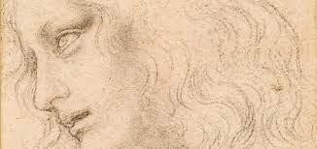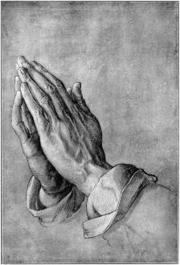  (1) |  | Collage – Pablo Picasso  Building on the work with natural objects in FS1. Introducing the children to tearing, cutting and manipulating materials.  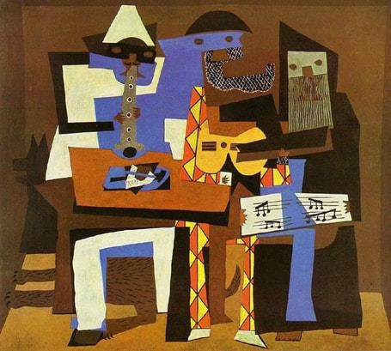  (EYFS) |  | Textiles – Henri Rousseau  This unit builds on the weaving unit from FS2. The children will now use stiches to join fabric and use applique to add depth  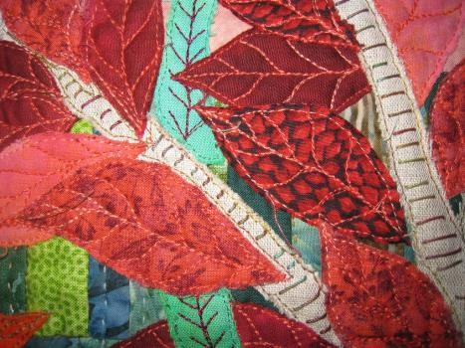  (EYFS)
Computing
Route explorers (1)  The internet  Online safety  – Self image and self identity  - online relationships  (1) | The Internet  Creating Pictures  (1)  Online safety  -Online reputation  Online bullying  (1) | Spreadsheets  (1)  Online safety  -Health, wellbeing and lifestyle  (1) | Questioning  Online Safety  - Privacy and security  (1) | Coding  (1)  Online safety  - Managing online information  - (1) |  | Presenting Ideas  Making Music  (1)  Online safety  - Managing online information  - Copyright and ownership  (1)
Music
Pulse, rhythm and pitch  (1) | Playing in an orchestra  (1) | Inventing a musical story  (1) | Recognising different sounds  (1) | Exploring improvisation  (1) |  | Learning to play an instrument: the recorder
Physical Education
Fundamentals  (1)  Team Building (1) | Gymnastics  (1)  Fitness  (1) | Dance  (1)  Target games  (1) | Net and wall games  (1)  Sending and receiving  (1) | Ball skills  (1)  Striking & fielding  (1) | Athletics  (1)  Invasion games  (1)

